**PROJECT** **DOCUMENTATION**

FITFLEX

1. **INTRODUCTION**

* **Project Title:** Fitflex
* **Team ID:** NM2025TMID37028
* **Team Leader:** Selvadharshini**.**M

[Selvadharshini701@gmail.com](mailto:Selvadharshini701@gmail.com)

* **Team members:**
* Shobana.K – [shabanak2006@gmail.com](mailto:shabanak2006@gmail.com)
* Shajeena.R – [sajnapubg97@gmail.com](mailto:sajnapubg97@gmail.com)
* Shameera Farhana.R – [samifarahana0803@gmail.com](mailto:samifarahana0803@gmail.com)

1. **PROJECT OVERVIEW**

* **Purpose:**

Fitflex is a fitness and wellness platform that helps users track workouts, manage diet plans, and connect with trainers through a seamless and interactive interface.

* **Features:**
* Workouts tracking and progress monitoring.
* Personalized diet recommendations.
* Trainer-client chat system.
* Goal setting and achievement tracker.
* Admin control panel.

1. **ARCHITECTURE**

* **Frontend:** React.js with Bootstrap and Material UI
* **Backend:** Node and Express for server logic and API endpoints
* **Database:** MongoDB to store user profiles, workout data, diet plans, and chat history

**4.SETUP INSTRUCTIONS**

* **Prerequisites:**
* Node.js
* MongoDB
* **Tools:**
* Git
* React.js
* Express.js
* Mongoose
* Visual Studio Code
* **Installation Steps:**

# clone the repository

git clone <repo-link>

# Install client dependencies

cd client

npm install

# Install server dependencies

cd ../server

npm install

**5.FOLDER STRUCTURE**

Fitflex

|--client/ #React frontend

| |-- components/

|

|--server/ #Node.js backend

|--routes/

|--models/

|--controllers/

**6.Running the Application**

* Frontend:

Bash

cd client

npm start

* Backend:

Bash

cd server

npm start

* Access:Visit <http://localhost:3000>

**7.API Documentation**

User:

* POST/api/user/register-Register a new user
* POST/api/user/login-User login

Workouts:

* POST/api/workouts/create-add workout
* GET/api/workouts/:id-Get workout details

Diet Plans:

* POST/api/diet/create-Create diet plan
* GET/api/diet/:userId-Get diet plan by user

Chats:

* POST/api/chat/send-Send message
* GET/api/chat/:userId-Get chat history

**8.Authentication**

* JWT-based authentication for secure login
* Middleware to protect private routes

**9.User interface**

* Landing page
* User dashboard(workouts and diet)
* Trainer dashboard
* Admin panel
* Progress tracker page

**10.Testing**

* Manual testing during milestone
* Tools: postman, chrome dev tools

**11. Screenshot or demo**

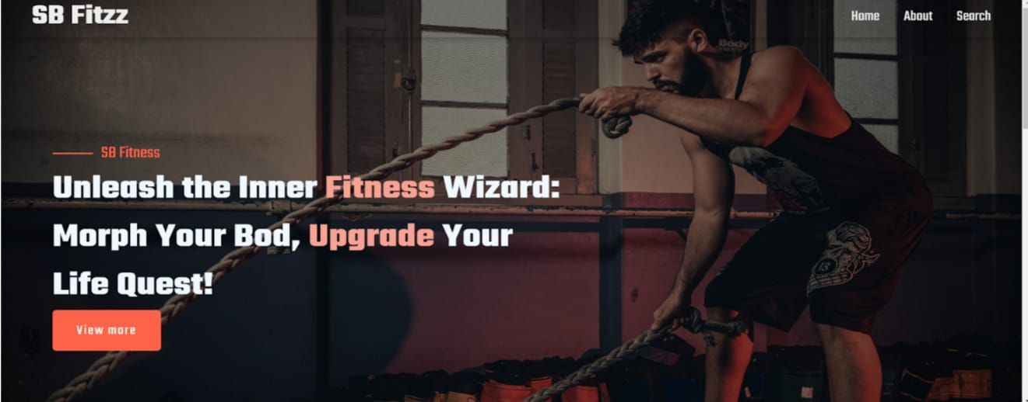

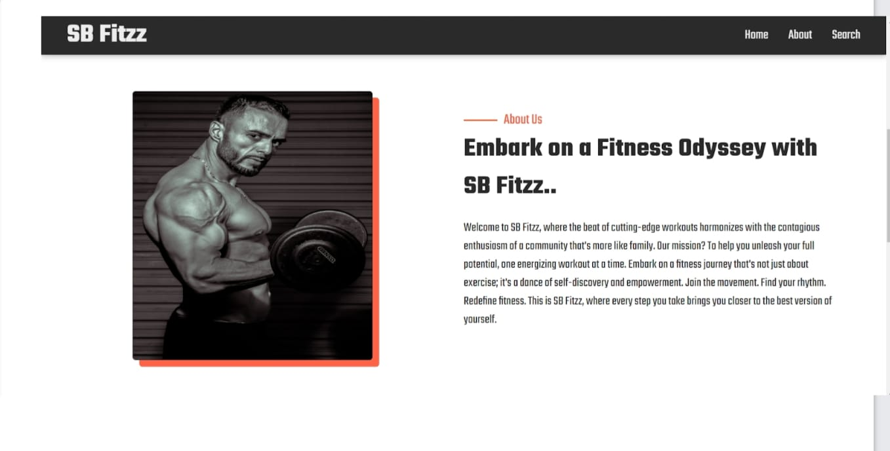

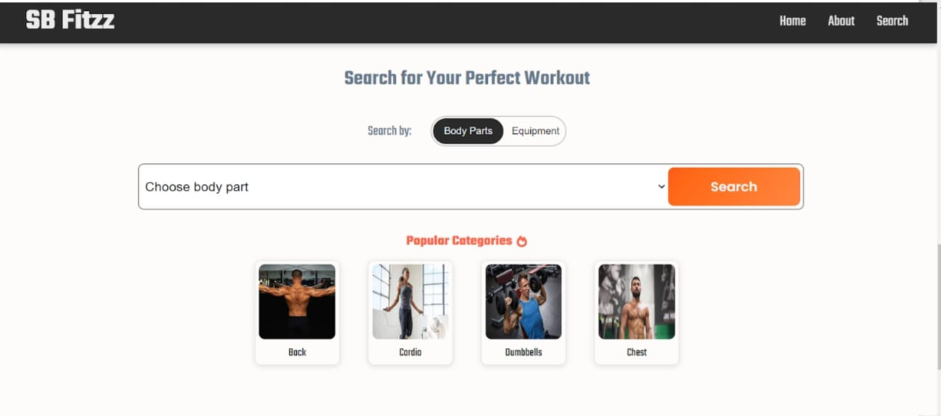

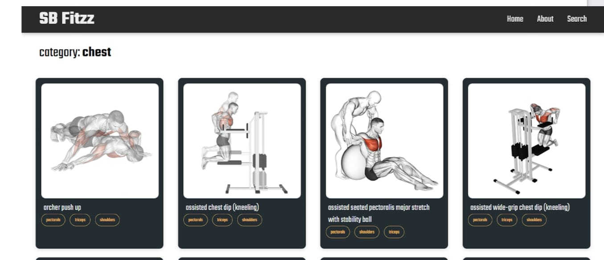

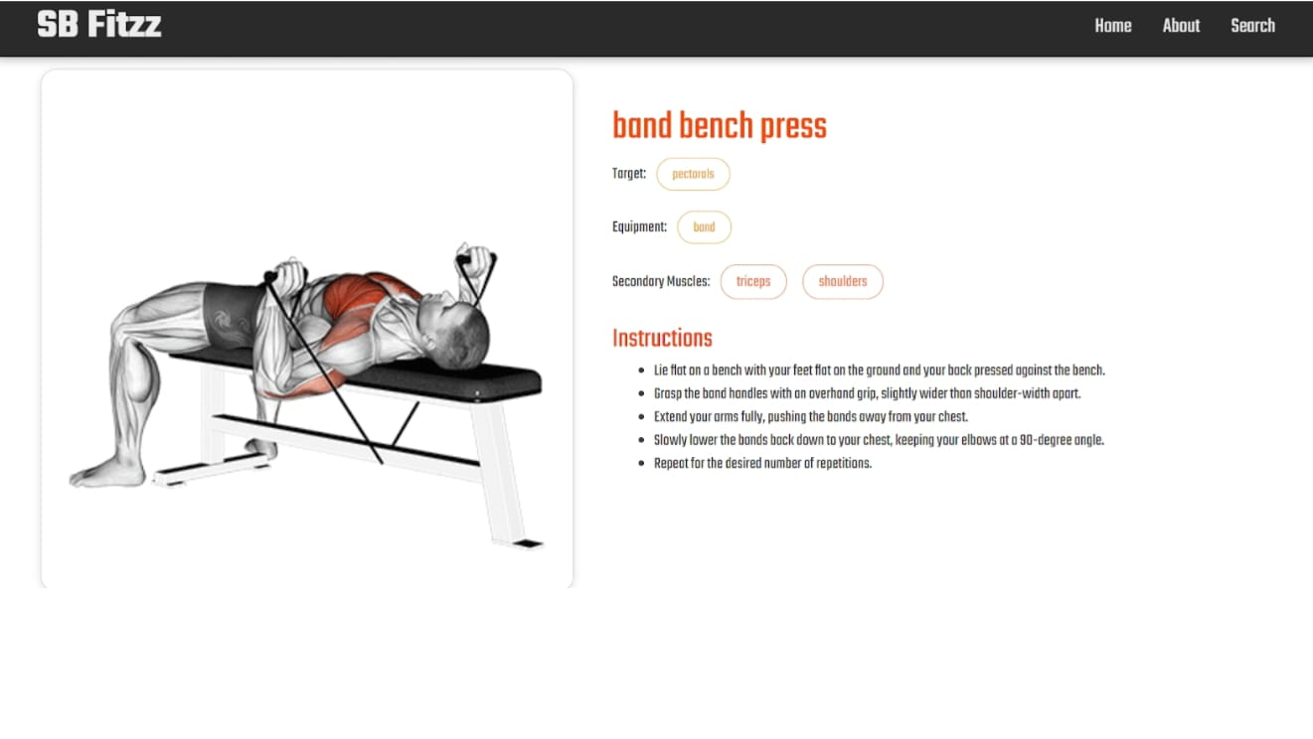

**12.Known issue**

* To be updated during testing phase

**13.Future enhancements**

* Mobile app integration
* AI-based workouts suggestions

Social fitness community features